***ANALYSING HOME PRISES IN METROPOLITAN AREAS IN INDIA***

***INTRODUCTION :***

OVERVIEW :

**House price prediction in a metropolitan city in India is a valuable solution forpotential home buyers, real estate agents, and investors. By leveraging historical sales data, property details, and location-specific information, a predictive model can accurately estimate house prices. The model's scalability, real-time updates, user-friendly interface, and transparency ensure it meets the needs of stakeholders. Integration capability, data privacy, and costeffectiveness are also important considerations. By addressing these requirements, the prediction model provides reliable insights, empowering stakeholders to make informed decisions in the fast-paced real estate market.**

***PURPOSE :***

**House price prediction in a metropolitan city in India is a valuable solution for potential home buyers, real estate agents, and investors. By leveraging historical sales data, property details, and location-specific information, a predictive model can accurately estimate house prices.**

#### 

PROBLEM Definition & Design Thinking

**EMPATHY MAP**

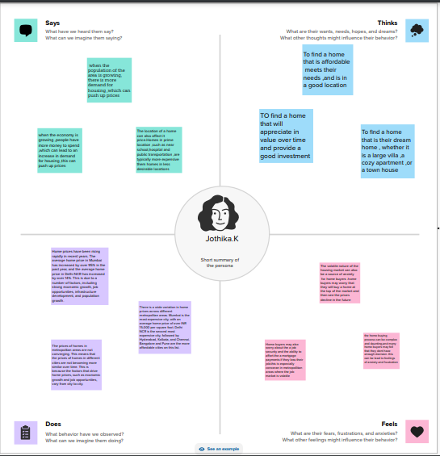

***IDEATION & BRAINSTROMING MAP***

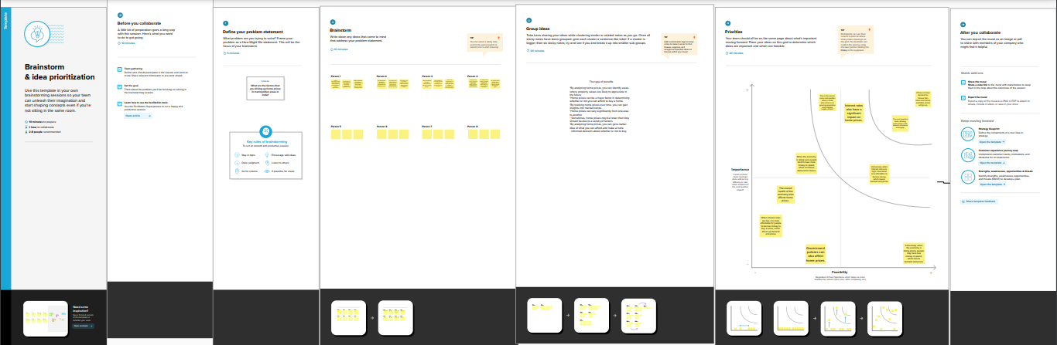

***RESULT:*** 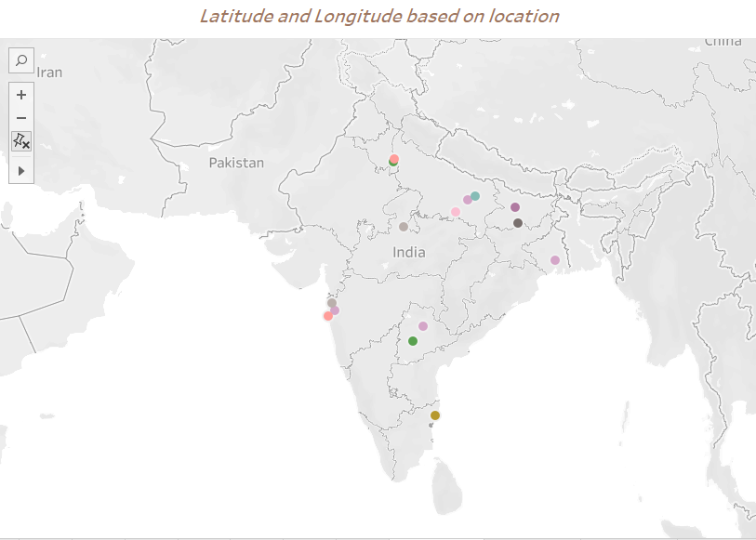

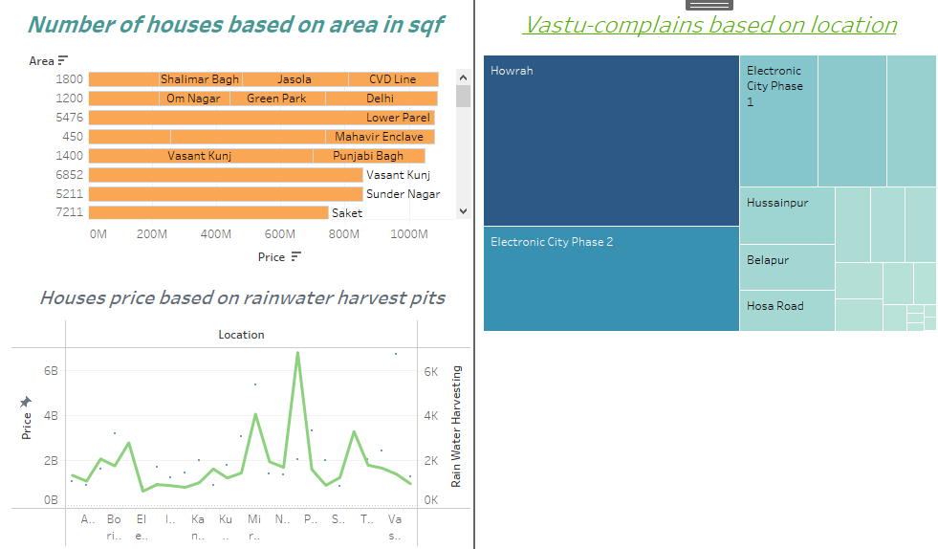

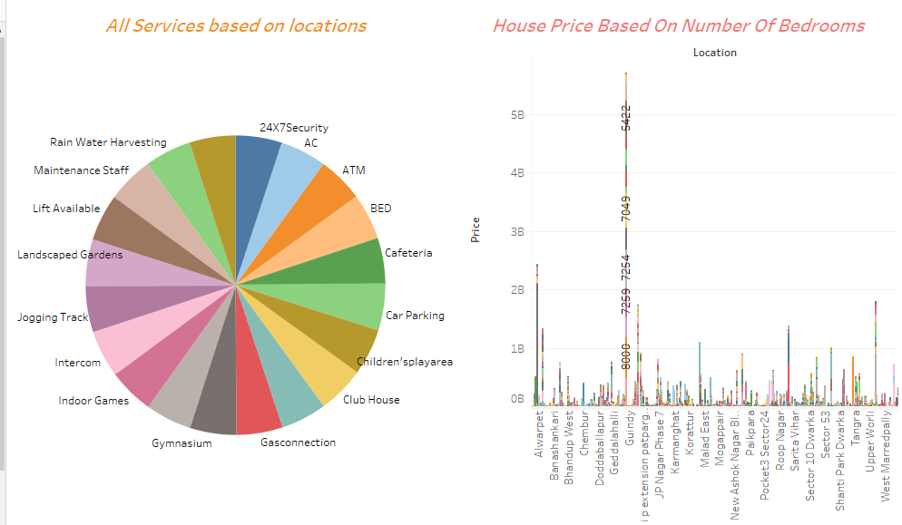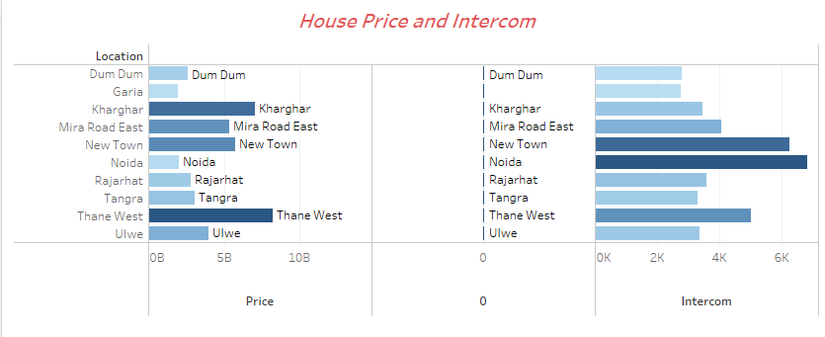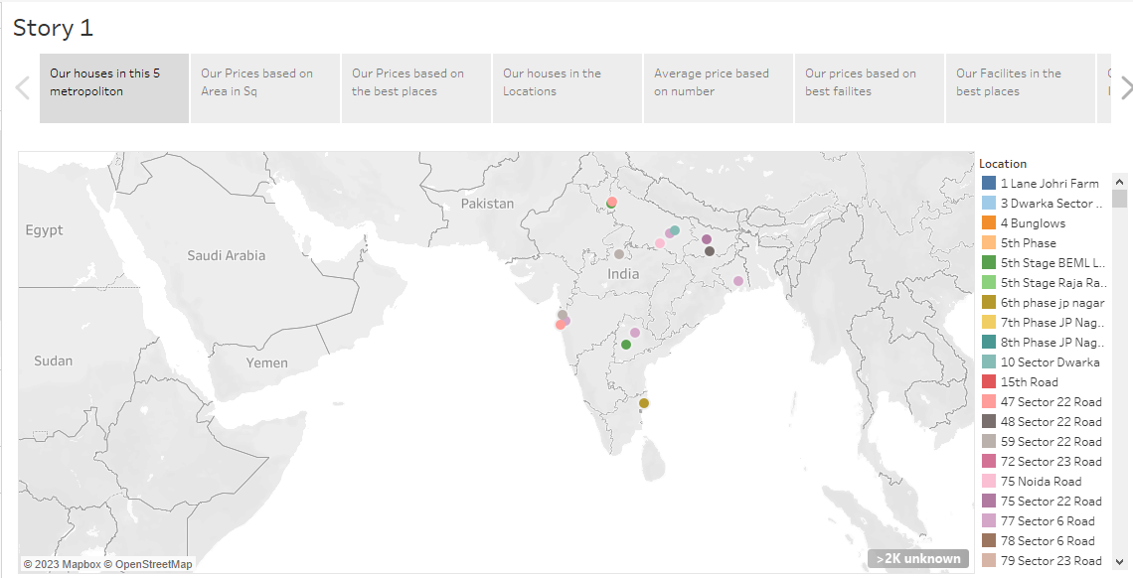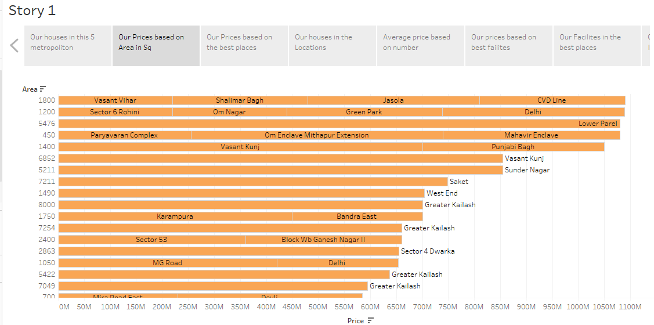

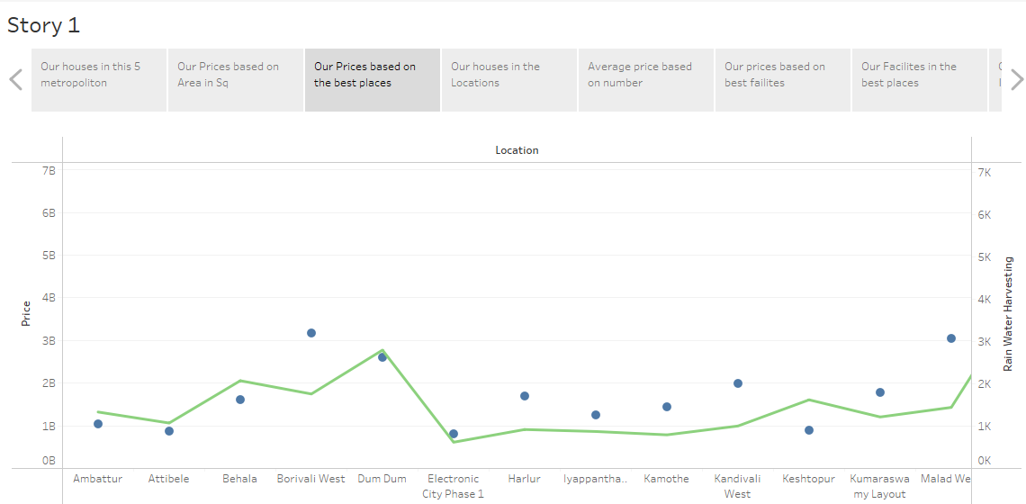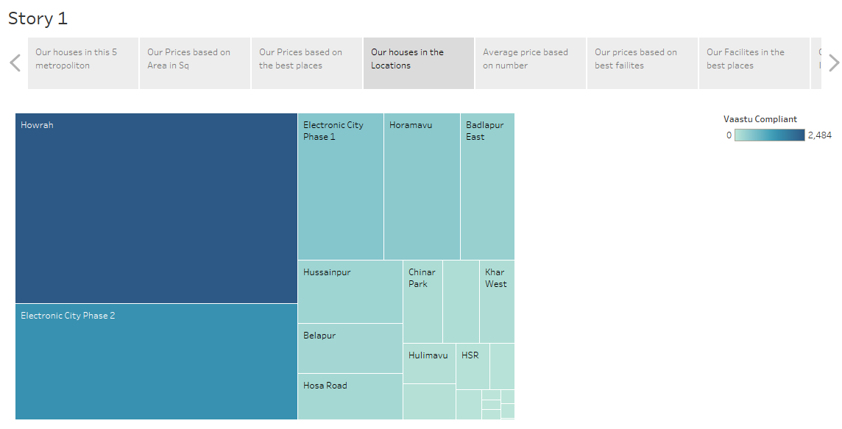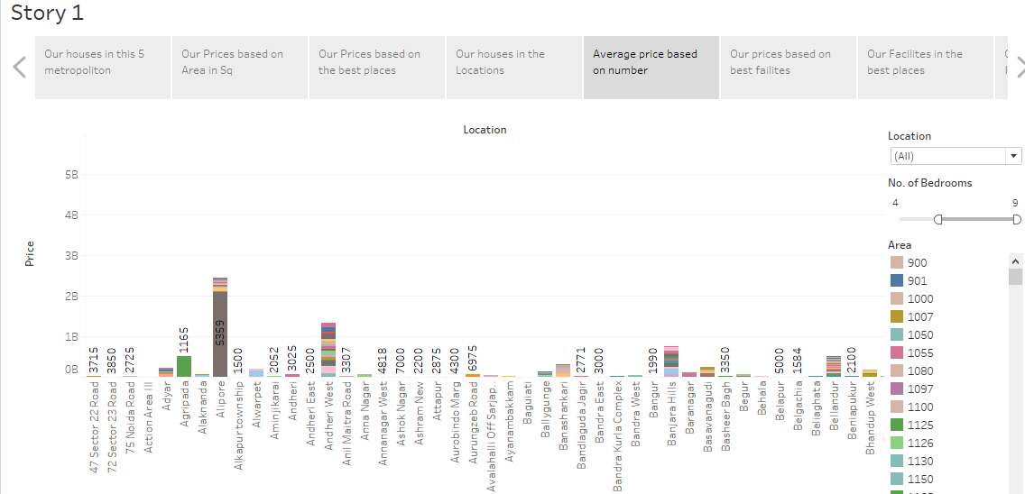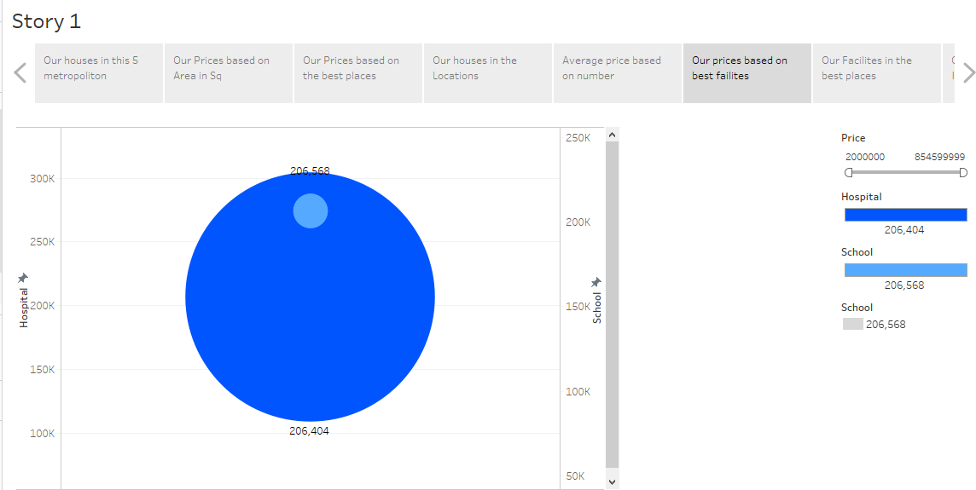

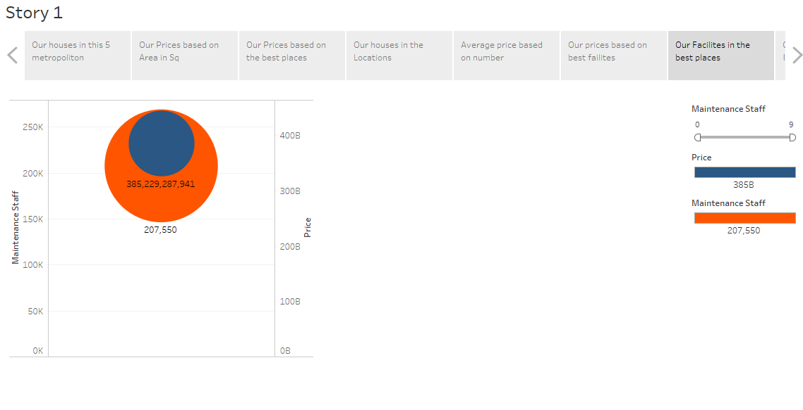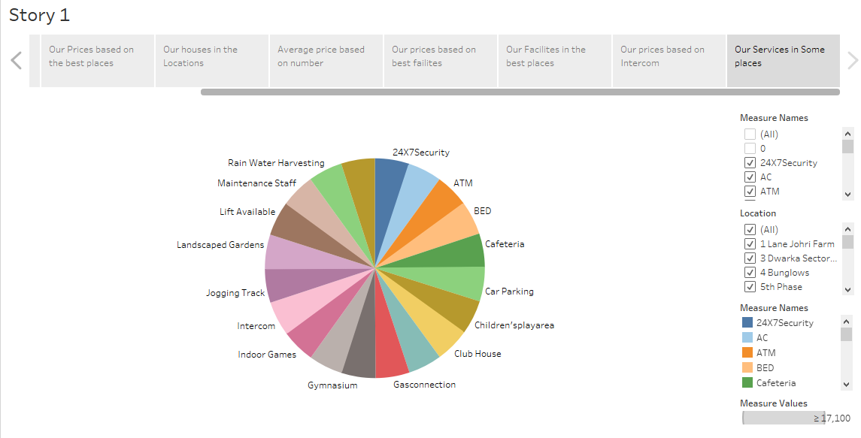

***ADVANTAGES :***

* **MARKET ANALYSIS IN REAL ESTATE IS SIMPLY A PROCESS OF GAINING A DEEP UNDERSTANDING OF THE REAL ESTATE MARKET.**
* **IT WILL GUIDE YOU FOR THE RIGHT TIME TO INVEST IN A PROPERTY AND A WISE INVESTOR ALWAYS GOES THROUGH THE MARKET ANALYSIS BEFORE INVESTING IN ANY PROPERTY.**
* **HOUSE PRICE PREDICTION CAN HELP THE DEVELOPER DETERMINE THE SELLING PRICE OF A HOUSE AND CAN HELP THE CUSTOMER TO ARRANGE THE RIGHT TIME TO PURCHASE A HOUSE*.***

***DISADVANTAGES :***

* **DATA ON HOME PRICES IN INDIA IS NOT ALWAYS READILY AVAILABLE OR RELIABLE. THIS CAN MAKE IT DIFFICULT TO CONDUCT ACCURATE AND MEANINGFUL ANALYSIS.**
* **THE INDIAN REAL ESTATE MARKET IS COMPLEX AND DIVERSE, WITH A WIDE RANGE OF FACTORS INFLUENCING HOME PRICES. THIS CAN MAKE IT CHALLENGING TO ISOLATE THE IMPACT OF INDIVIDUAL FACTORS.**
* **HOME PRICES CAN VARY SIGNIFICANTLY ACROSS DIFFERENT REGIONS OF INDIA. THIS MEANS THAT DATA FROM ONE REGION MAY NOT BE REPRESENTATIVE OF THE MARKET AS A WHOLE.**

***APPLICATION :***

**HOME BUYERS COULD USE HOME PRICE DATA TO COMPARE PRICES IN DIFFERENT NEIGHBORHOODS. THIS INFORMATION COULD THEN BE USED TO MAKE AN INFORMED DECISION ABOUT WHERE TO BUY A HOME. HOME SELLERS COULD USE HOME PRICE DATA TO SET A REALISTIC ASKING PRICE FOR THEIR HOME. IF THEY SET THE ASKING PRICE TOO LOW, THEY MAY LOSE MONEY ON THE SALE. HOME BUYERS AND SELLERS COULD ALSO USE HOME *PRICE DATA TO TRACK TRENDS OVER TIME. THIS INFORMATION COULD BE USED TO DECIDE WHEN TO BUY OR SELL A HOME.***

***CONCLUSION :***

**IN ADDITION TO POLICY INTERVENTIONS, IT IS ALSO IMPORTANT FOR INDIVIDUALS TO BE AWARE OF THE FACTORS THAT DRIVE HOUSE PRICES IN METROPOLITAN AREAS IN INDIA. THIS INFORMATION CAN HELP INDIVIDUALS TO MAKE INFORMED DECISIONS ABOUT WHERE AND WHEN TO BUY A HOME*.***

***FUTURE SCOPE :***

**THE INDIAN GOVERNMENT IS INVESTING HEAVILY IN INFRASTRUCTURE PROJECTS, SUCH AS METRO SYSTEMS, HIGHWAYS, AND AIRPORTS. THIS IS LIKELY TO BOOST REAL ESTATE DEVELOPMENT IN THE AREAS SURROUNDING THESE PROJECTS. THE INDIAN GOVERNMENT IS INVESTING HEAVILY IN INFRASTRUCTURE PROJECTS, SUCH AS METRO SYSTEMS, HIGHWAYS, AND AIRPORTS. THIS IS LIKELY TO BOOST REAL ESTATE DEVELOPMENT IN THE AREAS SURROUNDING THESE PROJECTS.**